PWA video 27

<https://www.youtube.com/watch?v=BHCk5TSNUkI>

Will use the form tag since it is the only one on page, could have used .add-recipe

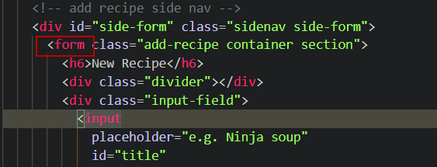

In DB file add recipe 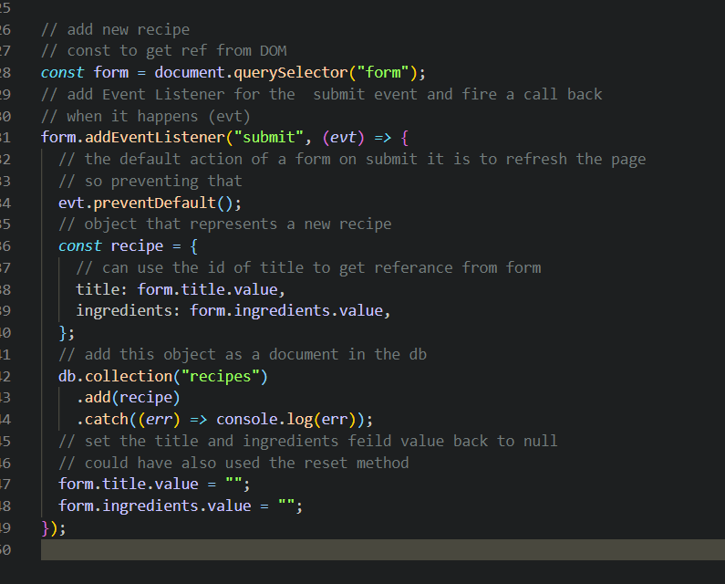

In the back ground firestore is syncing db so the new recipe when added files to the db when back online.